Higher Order component is a component that takes another component as an argument and return a new component with additional behavior. It allows us to share the common logic or functionality among the multiple component

App.js
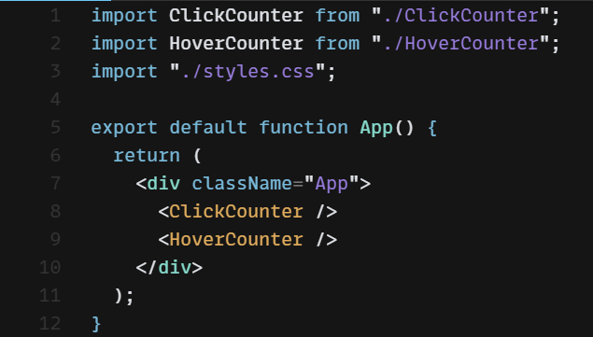

ClickCounter.js
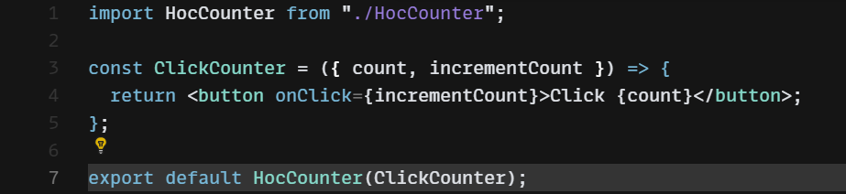

HoverCounter.js
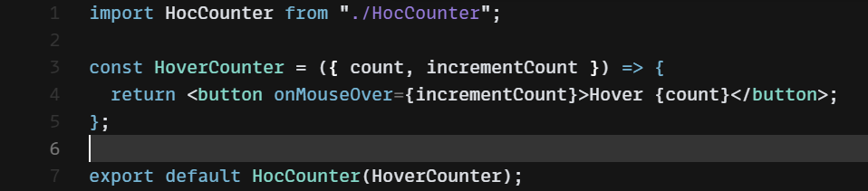

HocCounter.js
